

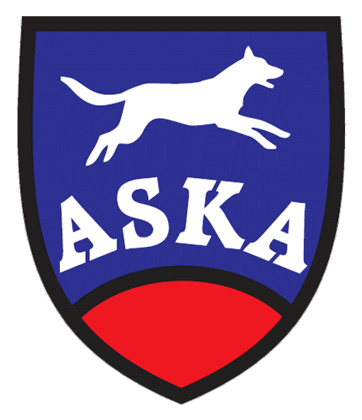
Agility Dobrý pes invites all agility friends to attend

AGI-HALLOWEEN
17th – 18th October 2015

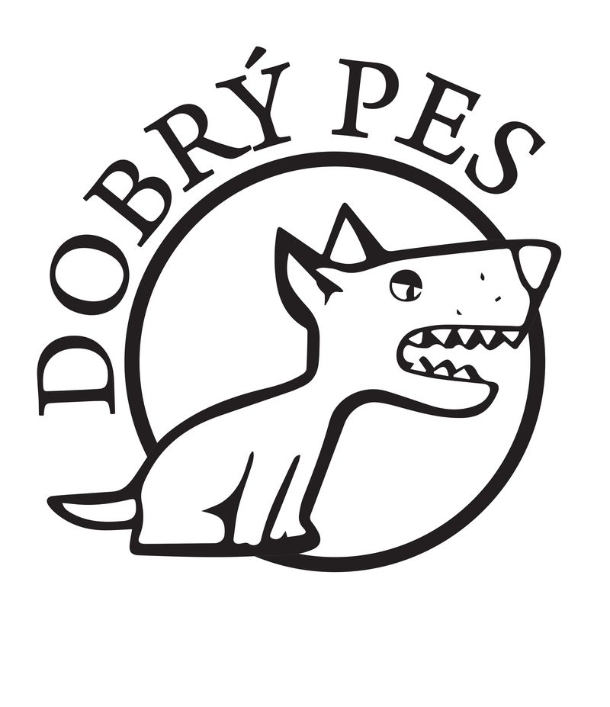
Organizer: Agility Dobrý pes
Location: Kamenný mlyn close Bratislava, Slovakia GPS 48°36181"N, 17°01738"E www.kamennymlyn.sk
Judge: Alex Beitl (D), Roman Lukáč jr.(SK)

Guarantee: Iveta Lukáčová

Program :

Saturday –17.10.2015 Sunday – 18.10.2015

8,00-8,45 Registration 8,00-8,45 Registration

9,00 start of the competition 9,00 start of the competition

Agility Open of the Best Bat Accursed Agility Open

Agility Open of the Best Witch Ghostly Jumping Open
Jumping Open of the Best Pumpkin Magical Jumping Open
Entry fee: 10,- Є team / day
Payment in advance, account number: 2626013419/1100 Tatra Banka
SWIFT: TATRSKBX Owner of account: Agility Dobrý pes
IBAN: SK48 1100 0000 0026 2601 3419 Tilgnerova 4. Bratislava
Variable symbol will send with entry form acceptation.
Payment by registration is possible just after agreement of guarantee.
Entry Deadline: October 12th 2015
General conditions: The competition is open for all dogs with a valid license or record book.
Prizes: All runs would be priced.
Veterinary conditions: Dog’s vaccination book or petpass prooving the valid vaccinations
General Terms: The competition is held according to the ASKA rules. The competition is organized on one course. The Organizer reserves right to change the program. Walking a dog is possible in a large forest outside the Kamenny Mlyn area. The handler is responsible for all demages caused by his dog. Protestation can be lodged after deposit of 20,- Є.
In a case of cancellation the competition caused by a force mayor the entry fee remains to organizer. The entry fee is not returnable. The organizer has the right to refuse any entryform.

The maximal number of competitors is 100!
Food, accommodation : Available in Kamenny mlyn – recreation area. Restaurant is next to course. Accomodation in rooms for 2 or 3 persons or bungalows. We recommend to book accommodation in advance, the best some months before the ation. Camping with caravans or tents is allowed as well.
Online booking of accomodation at: kamennymlyn@kamennymlyn.sk

The registration will be running on the webpage www.agilityportal.sk

There will be on the competition Exam Marathon 2015, Cup Mania 2015 and Agi – Halloween 2015 used new LED TV with diagonal 104 cm for showing the online results of each run. By the price giving ceremony of Agi – Halloween 2015 there will be a lottery of one winning competitor who attended all three competition named upper and who will win this LED TV.

Partners of the competition:







