


Slovak junior championship

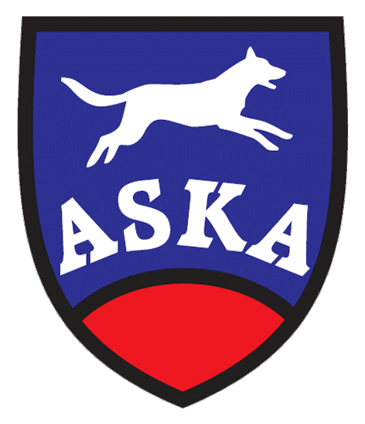
9th May 2015 and 10th May 2015

Organizer: Agility Dobrý pes
Location: Kamenný mlyn close to Bratislava GPS 48°36181"N, 17°01738"E www.kamennymlyn.sk
Judges: Manca Mikec (SLO), Roman Lukáč ml.(SK)

Guarantee: Roman Lukáč st.

Program:

Saturday – 9.5.2015 Sunday – 10.5.2015

8,00-8,45 Registration

9,00 start of the first run 9,00 start of the first run

Agility teams Jumping teams

Jumping individual children Agility individual children
Jumping individual juniors Agility individual juniors

Entry fee: 10,- Є team / two days
Payment in advance, account number: 2626013419/1100 Tatra Banka
SWIFT: TATRSKBX Owner of account: Agility Dobrý pes
IBAN: SK48 1100 0000 0026 2601 3419 Tilgnerova 4, 841 05 Bratislava
Variable symbol will be sent with entry form acceptation.
Payment by registration is possible just after agreement of guarantee.
Entry Deadline: 1st May 2015
General condition: Condition of competing at Slovak junior championship is in order with slovak Agility rules:
Condition of one Agility 1 without elimination.
Children: from year of birth 2001 (included)
Juniors: from year of birth 1997 – 2000 (included)
Prizes: There will be prizes for combination of individual and team runs. The tittle Slovak champion of juniors and children can get just competitor with slovak nationality or with permanent address in Slovakia at least for 6 months.
Veterinary conditions: Dog’s vaccination book or petpass prooving the valid vaccinations
General Terms: The competition is held according to the ASKA rules. The competition is organized on one course. The Organizer reserves right to change the program. Walking a dog is possible in a large forest outside the Kamenny Mlyn area. The handler is responsible for all demages caused by his dog. Protestation can be lodged after deposit of 20,- Є.
In a case of cancellation the competition caused by a force mayor the entry fee remains to organizer. The entry fee is not returnable, but i tis possible to move entryfee to another team.

The maximal number of competitors is 100!
Food, accommodation : Available in Kamenny mlyn – recreation area. Restaurant is next to course. Accomodation in rooms for 2 or 3 persons or bungalows. We recommend to book accommodation in advance, the best some months before the ation. Camping with caravans or tents is allowed as well.
Online booking of accomodation at: kamennymlyn@kamennymlyn.sk

The registration will be running on the webpage link www.agilityportal.sk/en/

Partners of the event:







