


Agility Dobrý pes invites all agility friends to attend Kamenný mlyn – Cup Mania
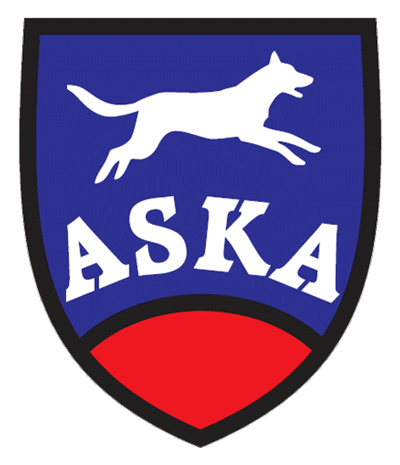
20th – 21st of June, 2015
Together with the 12th Slovak
Championship of Border Collies

Organizer: Agility Dobrý pes
Location: Kamenný mlyn close Bratislava, Slovakia GPS 48°36181"N, 17°01738"E
Judges: Wolfgang Tieber (A), Iveta Lukáčová (SK), Roman Lukáč jr.(SK)

Guarantee: Roman Lukáč

Program :

Saturday – 20.06.2015 Sunday – 21.06.2015

8,00-8,45 Registration

9,00 start of the competition 8,00 start of the competition

Agility Open Admiral Cup Jumping Open MERU Cup

Jumping Open Kon-Rad Cup Agility Open Kamenný mlyn Cup
Jumping Border Collies Agility Border Collies
Jumping Special Agility Special
Entry fee: 20,- Є team / 2 days
Payment in advance, account number: 2626013419/1100 Tatra Banka
SWIFT: TATRSKBX Owner of account: Agility Dobrý pes
IBAN: SK48 1100 0000 0026 2601 3419 Tilgnerova 4, 841 05 Bratislava
Variable symbol will be sent with entry form acceptation.
Payment by registration is possible just after agreement of guarantee.
Entry Deadline: June 14th, 2015
General conditions:
  - Jumping and Agility Border Collies (The Slovak Championship of Border Collies) are open for all Border Collies with a pedigree recognized by FCI.
  - Jumping and Agility Special are open for all dogs except Border Collies with a pedigree recognized by FCI.
  - All other courses are open for all dogs with a valid license or record book.
Prizes: Total of Jumping Border Collies and Agility Bordercollies – Slovak Champion of Border Collies 2015
Total of Jumping Special and Agility Special – Winner of Special cup (open runs for all dogs except Border Collies)
The sponsors of the competition present cups for the first 3 competitors of each open run.

Veterinary conditions: Dog’s vaccination book or petpass prooving the valid vaccinations
General Terms: The competition is held according to the ASKA rules. The competition is organized on one course. The Organizer reserves right to change the program. Walking a dog is possible in a large forest outside the Kamenny Mlyn area. The handler is responsible for all damages caused by his dog. Protestation can be lodged after deposit of 20,- Є.
In a case of cancellation the competition caused by a force mayor the entry fee remains to organizer. The entry fee is not returnable, but i tis possible to move entryfee to another team. The organizer has the right to refuse any entryform.

The maximal number of competitors is 130!
Food, accommodation : Available in Kamenny mlyn – recreation area. Restaurant is next to course. Accomodation in rooms for 2 or 3 persons or bungalows. We recommend to book accommodation in advance, the best some months before the ation. Camping with caravans or tents is allowed as well.
Online booking of accomodation at: kamennymlyn@kamennymlyn.sk

The registration will be running on the webpage www.agilityportal.sk

There will be on the competition Exam Marathon 2015, Cup Mania 2015 and Agi – Halloween 2015 used new LED TV with diagonal 104 cm for showing the online results of each run. By the price giving ceremony of Agi – Halloween 2015 there will be a lottery of one winning competitor who attended all three competition named upper and who will win this LED TV.





Partneri podujatia:


